PENGOLAHAN CITRA DIGITAL

PRAKTIKUM 5

___________________________________________________________________________

Nama: Zidan Nuryawan Pratomo

Kelas: C-TKK

Nim: 1207070132

__________________________________________________________________________________

1. Brightness, Contrass, Autolevel Contrass:

Hasil output gambar disatukan dalam 1 figur dengan 7 buah subplot;

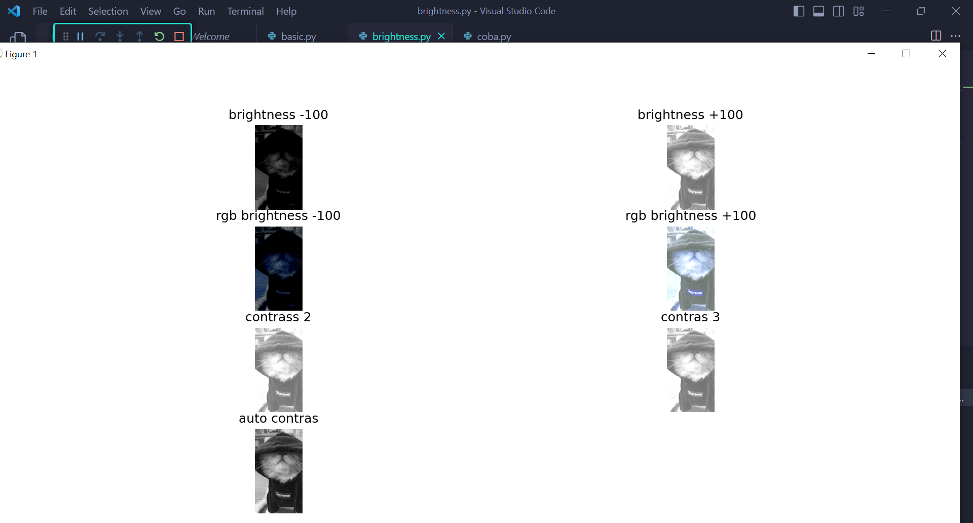

1. Oprasi dasar citra

Output pada terminal:

Berisi besaran dimensi gambar mulai dari gambar asli , dan gambar hasil crop

Output gambar:

1. Cropping

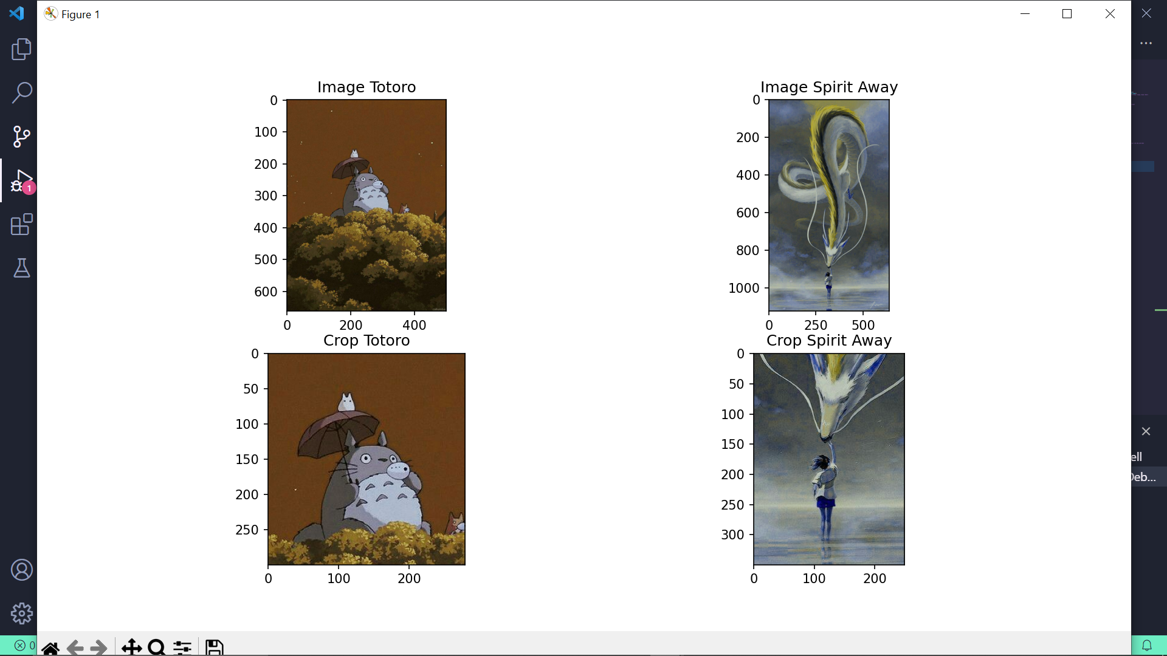

1. Citra Negative / inverted image beserta histogramnya

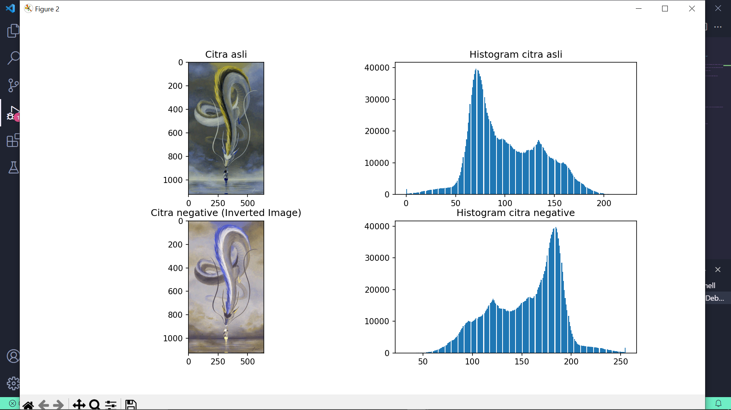

1. Citra Penambahan Brightness berserta histogramnya

